Red Eye

I called myself an artist at times. Not just an artist. I was an amateur artist that would sit in coffee shops. Yes, I am the girl in the white-knit sweater that sits alone in the corner with my venti soy latte in the palm of my hands in hopes that bystanders would recognize that I am an aesthetically pleasing, all-American, unoriginal girl. I didn't even like coffee. I used the smell of insomniac students with caffeine on their breaths as motivation. The sound of the baristas grinding coffee in the morning reminded me of a metronome and how I had to focus on the noise which drew the work itself. I found myself later in the day with the smell of coffee stained into my clothes, but it was actually the napkins in my pockets that I sketched on and stole from the store to remind myself that I sat in coffee shops for literally no fucking reason.

I have an art journal where I would recollect my concentrations. I used to bring my pack of expensive, multicolored pens to the shops and often sat for hours identifying which direction I should move my pen in hopes it would create something beautiful. I never allowed anyone without any artistic background to use my pens even if they did not have one for class. It was too expensive for a person with no artistic ability to be damaging. My pen would move to the left and around and somehow it would become an art. To start a sketch on a blank canvas and to finish with a completed picture was unimaginable when imagining what to.

My favorite thing to draw is faces. Sometimes when I sat in coffee shops, I would observe the people that came in. I would sit on the stools lined up against the windows and stare at the zombies that would stand or wait in line for a six dollar, six-ounce cup of milk that would have them wired for maybe an hour or two. Their faces were different every time.

I specifically loved drawing the face of a female. I would observe girls and get a glimpse of their personalities and facial structures which was easier to depict the imperfections of a face when all I did was pay attention to detail. Groups of girls came in-and-out and sat down in packs. They did the same thing every time they came in for a cup of coffee. They never did any of their homework but made any excuse to show their decorative laptop stickers or friendship bracelets attached to their hydro flasks they previously made the night before. The conversations consisted of nothing that truly mattered and made me feel as if the world would genuinely end if Becky didn't get her grande iced coffee with three ice cubes before class-- It was unflattering and annoying. A nose was slightly crooked to the left with a smaller indented nose bridge that had one, too many blackheads. An eye would be higher than the other and I wondered if they even noticed it. A mouth had plump lips which created a larger than enormous, unappealing smile once it was open— It always bothered me and I could not help but notice it. I’ll keep that to myself though.

I saw a particular face that created a silence that slowly but surely made its way into a caffeinated atmosphere. It was a moment when the sound of faint rock music and distant chatter faded, the sea had parted, and all that was seen was one distinct angel.
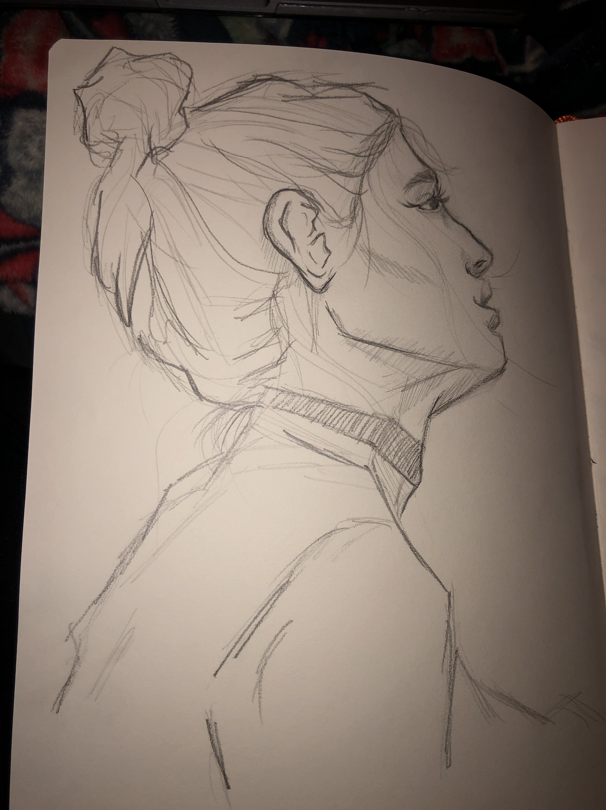
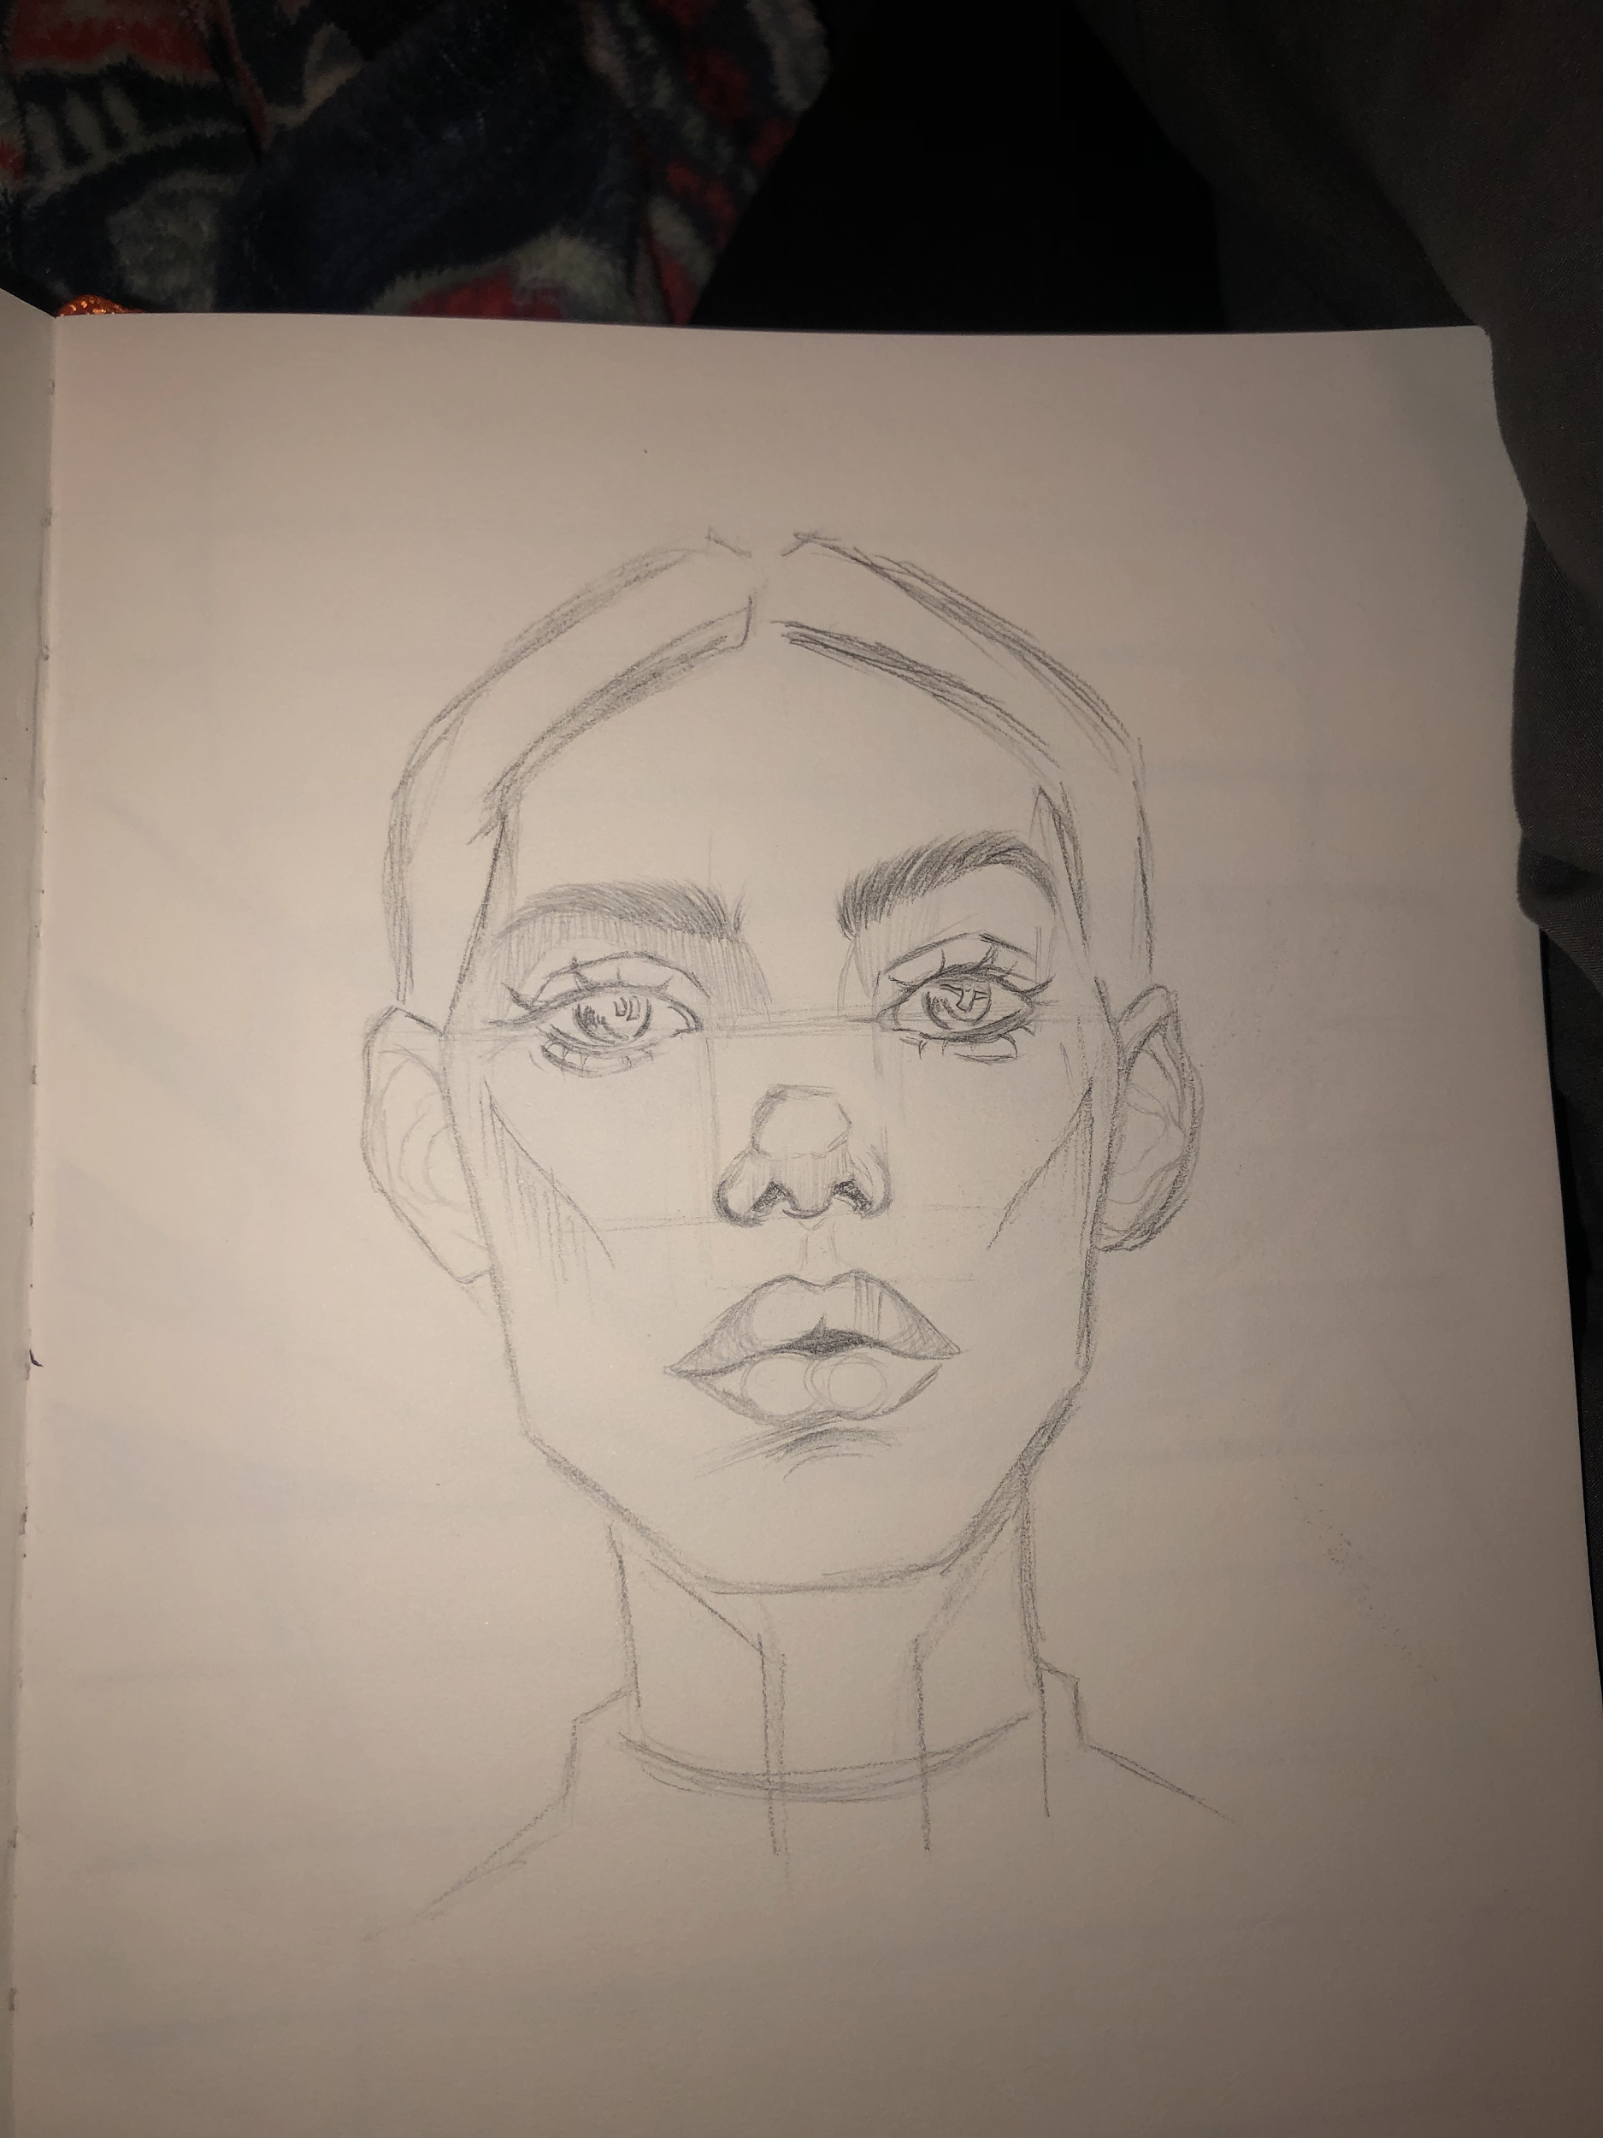
A stranger. She had a fresh face that walked in with pure gracefulness and a desire for the most simplistic things in life. Happiness surrounded her presence and it could be seen in a way that was not from decorative laptop stickers. I couldn't figure out why she looked happy. Maybe it was the idea that she would be getting coffee? Or was it the way her cheekbones would raise when she let out a small smirk? The parts of her face were put together as if the hands of God designed them himself. There were plump lips that peaked pristine, glossy teeth underneath them and a tall nose that curved upwards which she used to enjoy the aroma of a red-eye coffee. Her hair was thrown into a bun that drooped ever so slightly and loose hairs that hung from her forehead from the knocking wind. She had thick brown eyebrows that drew attention to her frosted eyes— the eyes that would gaze flakes of emerald ice. Looking back, the eyes gave me a portrait.

I picked up my pencil and began to sketch a portrait of the angel, unbeknownst to her. I didn't have to steal any napkins and stash them in my pockets because I had everything I needed at the moment. I was alone, at the table, staring at the curves of her face from the forehead to her chin. She took a glance around the room, gradually moved closer to my proximity, and ended her journey in the seat in front of me. What an angle. She sat with the lyrics of songs bouncing against the walls of her head as I started a new portrait head-on. Her face was undeviating and pointed in my direction. I started with her head, followed through the tee of her face, to her plump lips and high cheekbones, then the flakes of emerald ice in her eyes. I looked down to correct the caricature mistakes upheld on the surface of the paper and I was finished. My angel was complete, another page in my journal. I proudly secured my journal, let out a sigh of happiness only to notice the sea had parted once more. All that was seen was a stalker drawing a portrait of a girl.

Shit.

