

Social Media Audit of Bumble
on Facebook, TikTok, and Instagram

From June 26, 2020 to July 3, 2020

By Candice Nguyen
July 16th, 2020
Part I: Background
- The brand I am looking at is Bumble, a social networking app in which female users can make the first contact with other users between different modes such as "Date, BFF, and Bizz".

According to Bumble's website, their mission statement is "Make the first move." The company uses this initiative as a movement to shift the power dynamic between males and females. Bumble encourages equality, respect, kindness, integrity, and confidence to maintain healthy connections between its users. Bumble's overarching goal is to build connections whether it be romantically, for a personal network, or lifelong friendships.

This dating app has gained popularity since it was established in 2014 compared to its competitors because the woman must message after a match in order to communicate. The demographic of users on the app are men and women who are at least 18 or older in order to make a profile and start connecting. The main age range of users is 18-34-year-old male and female users with diverse backgrounds, though it encourages everyone to join the community.

- Bumble's Facebook Biography: "Bumble: Something better. Download now and find your honey. iOS + Android → bumble.com/?ct=DownloadBumble"
There is no direct indication that it refers to the mission statement or any other mode except for dating. It can be inferred that it is a dating app but does not indicate the idea of "defying traditional stereotypes" until one looks further into the page.

Bumble's Instagram Biography: "One app. Three modes. likeshop.me/bumble"
This references the different settings the app has in comparison to its competitors because it is the first app where users can make romantic, platonic, and professional connections. It also communicates that it offers more than just a simple dating app.

Bumble's TikTok Biography: "Making the first move. Also making TikToks. 18+"
This references Bumble's overall mission statement while also including a pun in which users can enjoy the content created. It also references the age a user must be when joining the app so it could censor the content for younger users.

Part II: Content Audit
Day 1 – June 26th, 2020
Platform and Reach | When/How Often  Posting | What Type Content & Sentiment for Notable Content | Overall  Feedback from Fans, Followers  to Content  (Likes/Comments) | Brand/Org Engagement with Fans, Followers  Response Time to User
Facebook  146,961 Followers | Did not post | N/A | Comments under previous posts receiving complaints or issues about the app | No responses
Instagram  532K Followers | Did not post | N/A | Positive responses under posts supporting activism | Typically within the same day
TikTok  14.5K Followers | 11 AM -- Posting at least every day, to every other day. | Content creator hand drawing a picture of African American woman -- "Black Lives Matter every day." | 9339 views, 835 likes, 10 comments, 2 shares | Only responded to one user within the hour showing agreement and cheer

Brief summary of day’s activity - Bumble had not been posting as often on Facebook out of respect for the Black Lives Movement but had been posting on other platforms to try to educate the community on equality. In early to late May they had posted multiple events within days of each other, but have not responded or posted events since then. Engagement within the TikTok comments has been large and the response time is quick, usually agreeing with the comments or cheering users. The engagement grows consistently every day with more views and likes on the platform.
Day 2 – June 27th, 2020
Platform & Reach | When/How Often  Posting | What Content & Sentiment  for Notable Content | Overall  Feedback  to Content | Response Time to Feedback to User
Facebook  146,961 Followers | Did not post | N/A | Comments under previous posts receiving complaints or issues about the app | No responses
Instagram  532K Followers | Did not post | N/A | Positive responses under posts supporting activism | Typically within the same day
TikTok  14.5K Followers | Did not post | N/A | Growth in followers from videos that consistently pop up on the"For You Page" | People posting and tagging @Bumble in their videos which they would respond/like their content within an hour

Brief summary of activity - There was a growth of followers on TikTok and positive responses back to users in the comments. I noticed there was a pattern in which the creators usually do not post as often on Saturday or Sundays which are the days they typically have lower engagement. Across other platforms, they do not seem to respond unless it is within the other of a recent post.

Day 3 - June 28th, 2020

Platform & Reach | When/How Often  Posting | What Content & Sentiment for Notable Content | Overall  Feedback  to Content | Response Time to Feedback to User
Facebook  146,961 Followers | Did not post | N/A | Comments under previous posts receiving complaints or issues about the app | No responses
Instagram  532K Followers | 1 post | Reminder to prioritize mental health in order to take care of others when needed -- Positive feedback | 2583 likes, 42 comments | Typically responds within the hour -- responding to comments with yellow hearts
TikTok  14.6K Followers | Did not post | N/A | Growth in followers from videos that consistently pop up on the"For You Page" | People posting and tagging @Bumble in their videos which they would respond/like their content within an hour

Brief summary of activity - Today was a better day for posting across their Instagram because the comments were positive in the sense that users were thankful for the reminder to prioritize themselves. It seemed as if their users were looking to hear something they needed on this day. Some verified users also engaged with the post with emojis. TikTok platform grew 100 followers within a day from previous posts showing up on the discover page through the algorithm. The account would also like and respond to other users' posts made about Bumble on TikTok with positive feedback.

Day 4 - June 29th, 2020

Platform & Reach | When/How Often  Posting | What Content & Sentiment for Notable Content | Overall  Feedback  to Content | Response Time to Feedback to User
Facebook  146,961 Followers | Did not post | N/A | Comments under previous posts receiving complaints or issues about the app | No responses
Instagram  532K Followers | Did not post | N/A | Positive responses under posts supporting activism | Typically within the same day
TikTok  14.8K Followers | 1 post -- 2 PM EST | Man dancing to a song while pointing out the states that can vote in the Summer Primary Elections -- Caption: "You heard him, get out and VOTE." | 11.3K views, 365 likes, 14 comments, 2 shares | No response to the comment section to give out political affiliation or opinion. They liked one comment that said "YES." within the hour

Brief summary of activity - There had been a surge of users on the Facebook page posting complaints about the app or customer service which Bumble did not respond to. TikTok platform had grown another 200 followers overnight and posted at 2 PM EST which is a prime time to engage in posting. There is also a pattern in which TikTok captions do not use hashtags which is very important to the algorithm when trying to gain traction on the app. Because the app uses republish or create content from designated users, it only tags the user and has a simple caption. They also do not tag trending songs which can bring more attention to the discover page but use the sound from the videos to claim as their own. Other users also commented under the app their political affiliations and the company did not respond.

Day 5 - June 30th, 2020

Platform & Reach | When/How Often  Posting | What Content & Sentiment for Notable Content | Overall  Feedback  to Content | Response Time to Feedback to User
Facebook  146,961 Followers | Did not post | N/A | Comments under previous posts receiving complaints or issues about the app | No responses
Instagram  532K Followers | 1 post | Asked a Bumble Ambassador how Black women experience misogyny and included examples-- Mostly positive, some negative | 1830 likes, 40 comments | Typically respond within the hour-- Comments responding to people who had issues with the app
TikTok  15.2K Followers | 1 post -- 6 PM EST | Video collage of a journey with a voiceover explaining that one should envision themselves to "Be the Main Character" | 13.5K views, 447 likes, 11 comments, 2 shares | Responded to two comments -- 1 like and a comment cheering a user (Less than 30 minutes)

Brief summary of activity - The Instagram post had positive and negative feedback because it speaks about how Black women experience misogyny. Bumble had responded to negative comments that explained how users have issues on the app or experienced racism with Bumble. Bumble responded with asking users to direct themselves to Facebook or Twitter for customer service help or connecting with their teams to fix their issues within the hour. TikTok had a growth of 400 followers and continued the pattern of using no hashtags under posts. The theme of today was mental health and how one should prioritize their life. The feedback to comments was positive and cheering users on the app. There was no follower count drop within the week. I believe it could have been a day where they could have also posted a TikTok that correlated to the Instagram post, but missed the opportunity.

Day 6 - July 1st, 2020
Platform & Reach | When/How Often  Posting | What Content & Sentiment for Notable Content | Overall  Feedback  to Content | Response Time to Feedback to User
Facebook  146,961 Followers | 1 post, 4:07 PM EST-- Event | Social media event during social distancing with Host to talk about Mental Health and how it should be prioritized health | 7 comments-- Mainly complaints about low response rates | No responses
Instagram  532K Followers | Did not post | N/A | Positive responses under posts supporting activism -- Negative for people who have customer service issues | Typically within the same day
TikTok  16K Followers | 1 post -- 2 PM EST | Girl hyping herself in a video to tell others that they are a "QUEEN" | 23K views, 1130 likes, 22 comments, 8 shares | Responded to three comments -- 3 likes and two comments responding to people who asked and dropping a crown emoji within 30 minutes

Brief summary of activity - First Facebook post since May 27th. Bumble used to be extremely active in posting events in which users can learn different topics or join live sessions. This is most likely due to the Black Lives Matter movement in which they previously paused all social media postings out of respect for the community. This event to be held on July 7th at 5 PM also announced a collaboration with Jack Burns of NAMI Greater Milwaukee, who will be speaking on mental health and answering any questions from the audience. There are negative comments under the post from users having service issues with the app which they demand Bumble respond. Bumble had not responded to any comments even on the day of the event. A lot of users across different platforms have complaints and issues with the app and are directed towards Facebook and Twitter, but it seems as if they do not respond through Facebook messages or comments. I believe it would be more efficient to direct messages Bumble with complaints rather than comments because the comments do not gain attention. The TikTok grew 800 followers and showed a video that correlated to the idea of mental health because it encourages self-confidence when one is feeling low. This post gained more traction than usual posts, but also did not have any hashtags in the caption. Bumble responded to users with positive feedback.

Day 7 - July 2nd, 2020

Platform & Reach | When/How Often  Posting | What Content & Sentiment for Notable Content | Overall  Feedback  to Content | Response Time to Feedback to User
Facebook  146,961 Followers | Did not post | N/A | Comments under previous posts receiving complaints or issues about the app | No responses
Instagram  532K Followers | 1 post | Story of a gay couple that matched in 2019 -- Positive responses | 5015 Likes, 117 Comments | Respond within the hour -- Responses talk about Bumble's inclusivity and diversity
TikTok  16.5K Followers | 1 post -- 2 PM EST | Girl describing what outfits she would wear on different dates | 32.5K Views, 1878 Likes, 25 comments, 4 shares | Within an hour-- Liked three comments, responded to 3 people updating on posts and saying "Hi" to users

Brief summary of activity - Slower follower engagement on TikTok in comparison to the last week of content being posted. In comparison, there was a larger video engagement gaining traction due to the number of views. The larger engagement on a video, the more views and attention the video will receive on the for you page. Bumble responded to comments with positive feedback. The engagement on Instagram was above average as it talked about a success story from the app. The comments were largely positive encouraging same-sex relationships. Bumble responded to comments speaking about their inclusivity with people of all sexual identities. The sentiments were far more positive than any other posts within the week.

Day 8 - July 3rd, 2020

Platform & Reach | When/How Often  Posting | What Content & Sentiment for Notable Content | Overall  Feedback  to Content | Response Time to Feedback to User
Facebook  146,961 Followers | Did not post | N/A | Comments under previous posts receiving complaints or issues about the app | No responses
Instagram  532K Followers | 1 post | Post of a tweet thread explaining the full existence of racism on an individual and systemic level -- Positive and negative feedback | 2796 Likes, 76 Comments | Respond within the hour -- Responds with customer service messages for people who experience racism from users
TikTok  20.6K Followers | 2 posts -- 2 PM EST and 8 PM EST | David Dobrik showing he is single on Bumble  --  Natalie Mariduena virtual dating and dancing | 44.3K Views, 4241 Likes, 88 Comments, 25 Shares  --  581K Views, 38.3K Likes, 361 Comments,  640 Shares | Within the Hour - 9 Liked comments, 6 responses to users responding to comments about Dobrik's use of the app and saying "Hi" to users  --  Within a day- 6 Liked comments, 5 responses agreeing with user's comments

Brief summary of activity - Today's Instagram post consisted of a list of microaggressions minorities face while in interracial relationships to explain how racism exists in an individual and systematic level. The level of engagement had dropped by receiving some negative feedback from users describing their issues with racism on the app. They had given positive feedback to those who had praised the list with hearts and also responded to negative feedback. The feedback included directing the users to customer support on Facebook and Twitter while trying to investigate cases that violate their community guidelines. The engagement levels were fair compared to other days but took a responsible amount of time to answer to both negative and positive comments.
On TikTok, they also revealed their partnerships with large influencers, such as David Dobrik and Natalie Mariduena, who created TikToks specifically for the Bumble platforms as well as in their own platforms as well. This drove engagement to over 4,000 followers in one day and increased the level of all previous videos tremendously. Users also commented on previous videos stating the reason they showed up to Bumble's platform was specifically due to the influencers. Bumble responded to comments in both videos with positive feedback and informed users of their presence on the app to allow more downloads. The engagement, specifically from Natalie, increased the views from the average of 20,000 views or less to more than half a million views on a single video overnight. The collaborations or "Bumble Partners'' directed a lot of engagement and attention towards the app.

Part III:
Overall Summary:
During my audit of Bumble from June 26 to July 3 on their three social media platforms Facebook, TikTok, and Instagram, it is clear that Bumble has a very active social media presence and engagement with its audience. Their overall social media platforms have accumulated 142,084 followers on Facebook, 23.2K on TikTok, and 532K followers on Instagram. Another social media platform they have is Twitter, though it is not included in this audit, it also indicates the mission statement and references to the three modes the app offers.
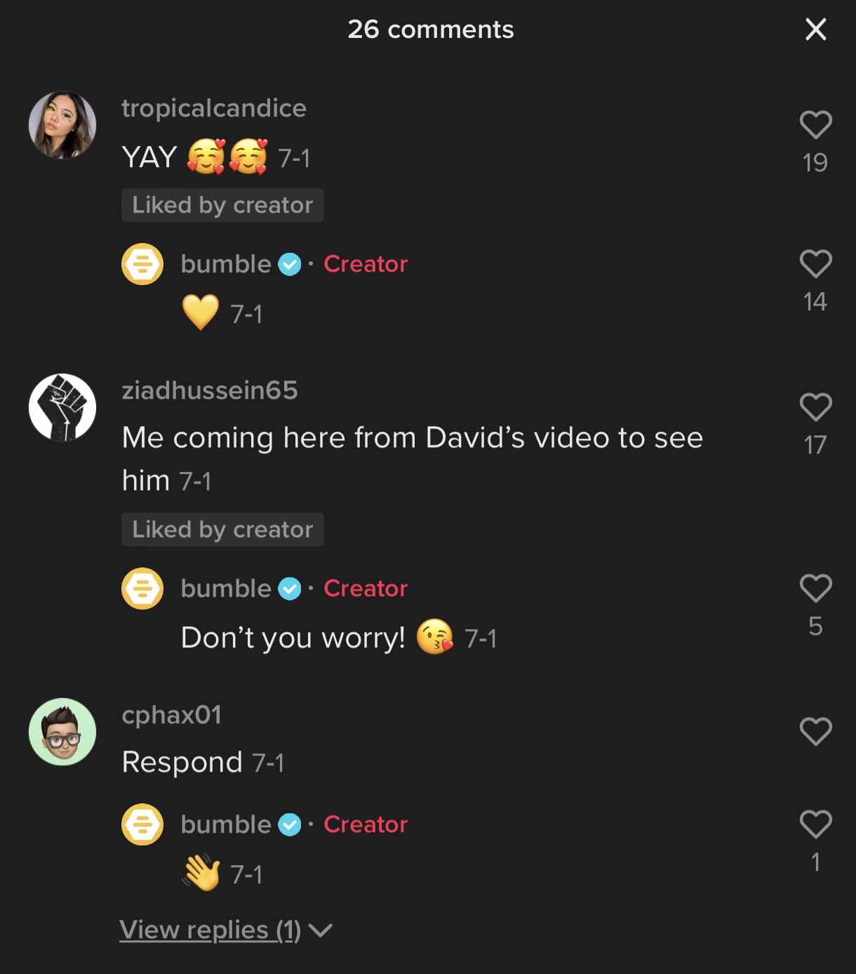
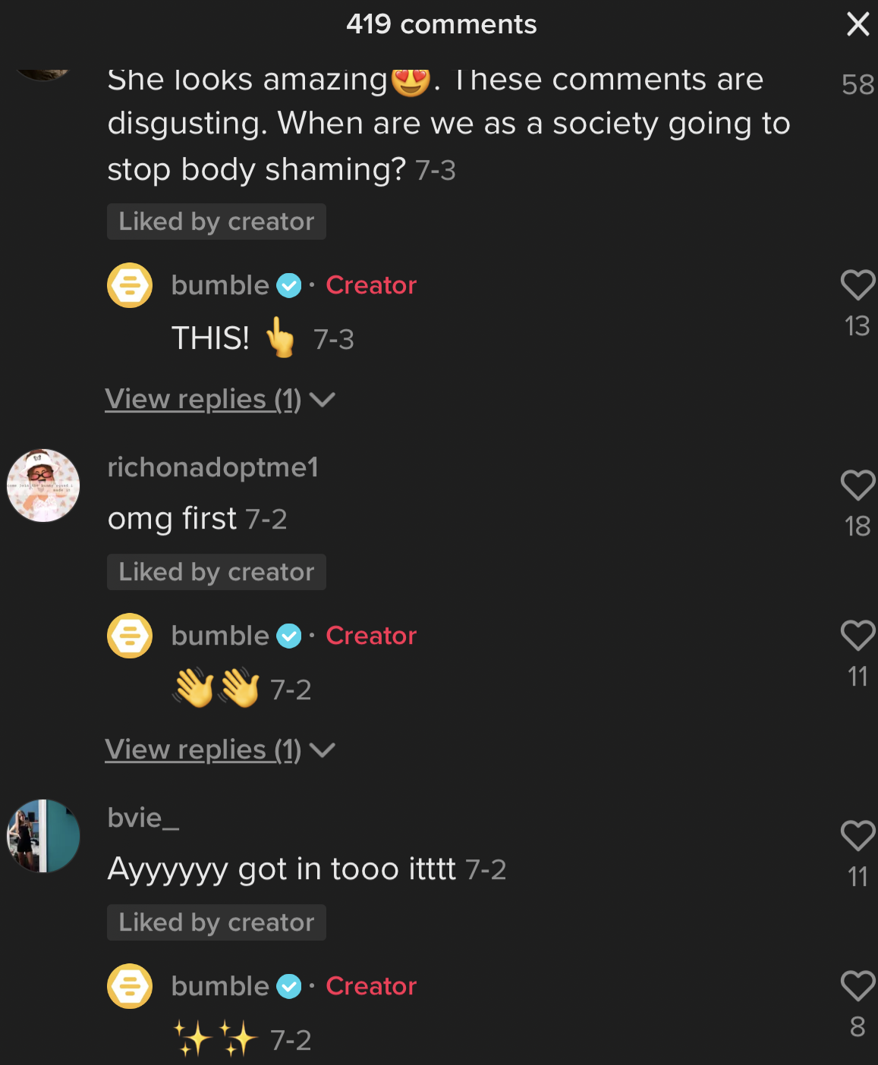
Starting with TikTok, I found Bumble's content generated excellent engagement with their audience with consistent postings every other day. TikTok is their best platform due to its target audience and demographic. According to Hootsuite's article, 14 Social Media Best Practices You Should Follow in 2020 by Todd Clarke, the best form of social media practice is learning everything there is to know about your audience to connect and engage. Because Bumble users must be 18 or older to use the app and roughly "26% of users are between the age of 18-24," Bumble can easily produce content that is specific to the demographic and encourage others to download (Omnicore). For example, the content creators on the app focus on lifestyle content that is funny and relatable to their core values which makes their brand more authentic and unique and results in more downloads compared to their competitors. Along with their active content, they are very responsive to comments from users, answering typically within the hour with positive or encouraging feedback only.
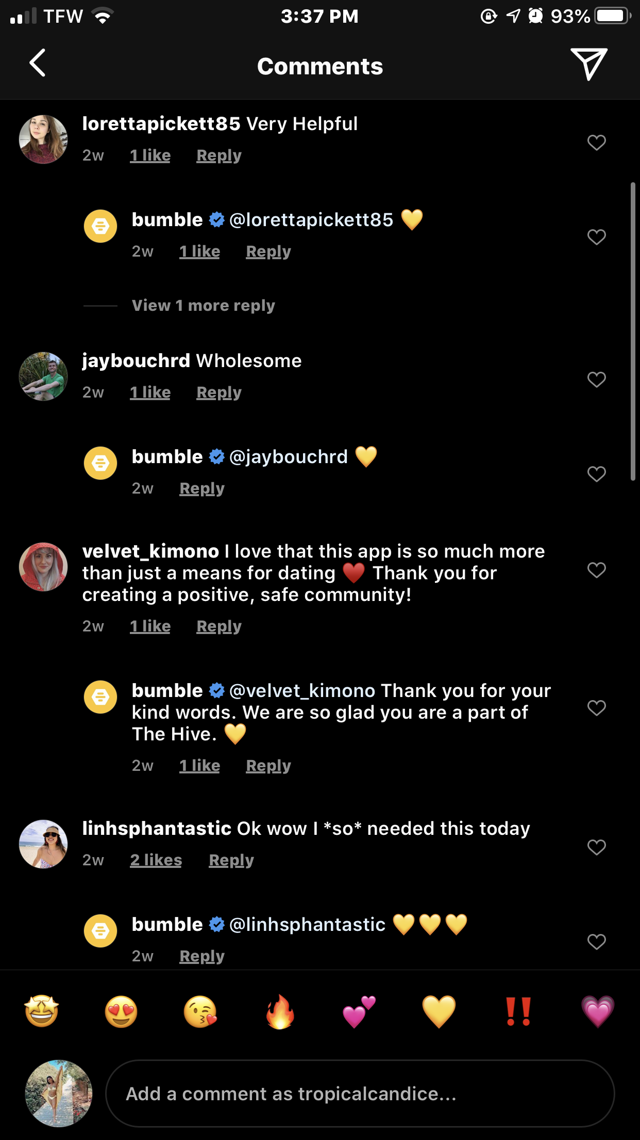
Todd Clarke's also says it’s important to "identify influencers and advocates," by revealing partnerships with influencers such as David Dobrik and Natalie Mariduena, which Bumble has done. By partnering up with the two, it drove engagement on Bumble's platform, increasing almost 4,000 followers overnight. TikTok creators on the app can drive their followers to engage with Bumble's platform just by being present on their social media. This can be emphasized with the images provided displaying the user's reason for being for coming across their platform in the first place. With partnerships with other large TikTok creators, Bumble's platform is growing every day.
When it comes to Bumble's content strategy, their posts are informative, educational, and motivational. Essentials of Social Media Marketing by Michelle Charello states, "No matter the industry or target market, it is vital for companies to tell a consistent and compelling narrative through visual content that engages followers." Bumble utilizes this strategy very well because of their vocal activism which also aligns with their core values, such as accountability, equality, kindness, respect, inclusion, and growth. Their Instagram posts consistently almost every other day with a large engagement rate with shares, likes, and comments due to their constant activism which develops a larger personal connection with their followers.
According to the BBC World Service article by Fernando Duarte, companies have been showing brand activism by taking a stand on different societal issues that are driven by consumer behavior as a positive contribution to society. Bumble continually creates posts supporting different humanitarian and social issues, but genuinely supports the cause which is largely identifiable by their values and postings within the audited week. Their community reaches beyond its target audience to ensure safety to the app and its users.
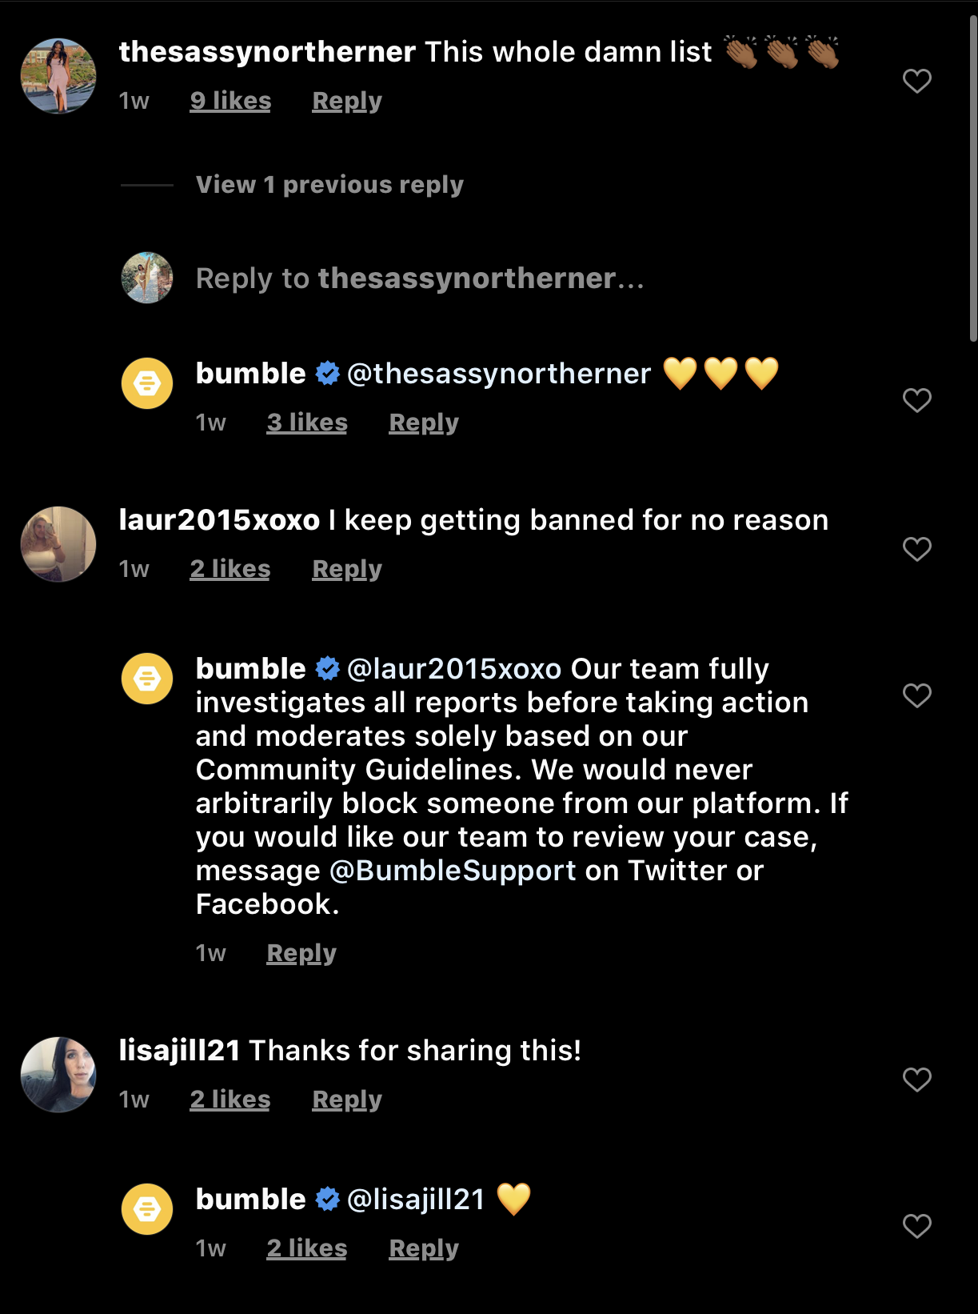
Though Bumble has a high engagement rate, their Instagram also responds to both positive and negative feedback from users. Most of the comments are mainly positive and Bumble responds to some with yellow hearts almost every time. Users who complain about the app usually will receive an automated message directing them to Facebook or Twitter for support. I will say that across Instagram, Bumble could be more genuine with their responses to different users because those who face issues within the app are directed to another platform.
Bumble's Facebook platform usually posts different online events where users can learn career tips, be aware of mental health, grow connections, and more. Bumble's response following the pandemic grew the app entirely because of their activism to keep users socially connected while at home. HubSpot's 5 Proven Social Media Engagement Strategies for 2020, indicates that provoking users to have conversations gives newcomers a way to express themselves which is what online users have with the Facebook events. By having a direct source to speak to consumers, the brand is able to give more engaging feedback to followers while being able to answer any questions about the given topic.
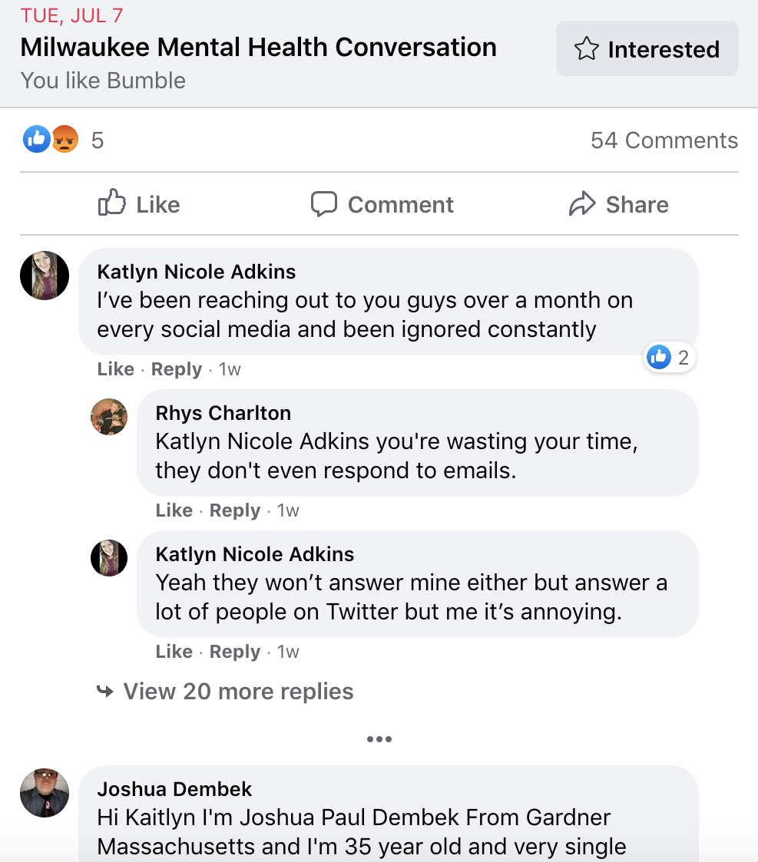
On Facebook, Bumble could improve its use of the platform by posting more regularly and consistently. It can be easily seen that Bumble does not post much on Facebook, but when they do, they publicize online forums and discussions for their users. Before the pandemic, Bumble's Facebook content consisted of announcements for virtual events, such as forums for career tips, happy hours and speaking with Bumble community leaders. In response to COVID, Bumble changed its events to be more sensitive to the online community. The events consisted of tips on online dating and blog posts to adhere to different ways to connect while socially dating.
Due to the Black Lives Matter Movement, Bumble halted all social media postings out of respect for the community. Since then, they have not made a collaborative effort to host any more online events or make general postings. Before, they had posted events almost every day in comparison to almost nothing currently.
Because their Instagram directs users who face any issues to the Facebook platform, users will post their complaints and then will receive no responses. This is a missed opportunity by Bumble because they could direct users to a service line to fix any bugs within the app. From a user standpoint, it seems as if they do not care to respond to any negative feedback if they are directed to another platform just to be ignored. Facebook can be improved greatly if they were to respond to the issues as insisted and posted more informative content besides events just like Instagram. It seems as if Bumble largely focuses on its Instagram platform in comparison to the other major social media platforms.
Overall, Bumble’s social media program is very consistent across its platforms as well as the content they produce. The company's core values include equality, respect, integrity, kindness, and confidence which can be seen through different events, content, and partnerships with other collaborators. On their Facebook page, there are different online events hosted in response to COVID-19 that include classes or live sessions to improve mental health, tips on how to build a network, and more. Instagram has different highlights including how to help different causes such as the Black Lives Matter, self-care, well-being, and how they give back. Their Instagram posts range from different success stories and how to educate oneself while adhering to the core values. The TikTok platform shows lifestyle content that focuses on dating tips, self-love or care, education, and awareness, as well as collaborators who use Bumble themselves to advertise the company. The consistency between all three platforms reflects positivity and equality which drives users and consumers to their app.

